Papers-To-Grade Organization System
Shared by Sharrer
Karla Sharrer
khsharrer@gmail.com

I have shared these resources that I created for free. Use them and share them for free as you like. I just request that unless you change more than 50% of the content, that you keep my name on the resources. Thank you.
-Karla

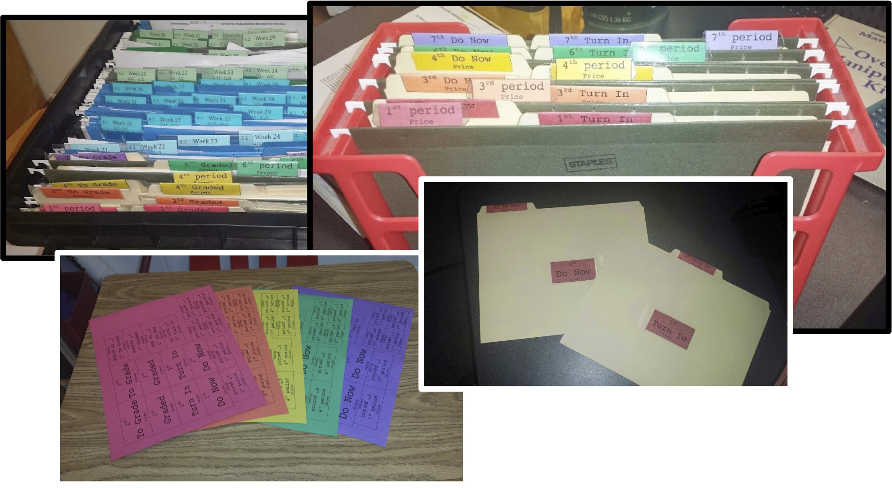
- Directions for Editing Labels:
Type “Control” + “F” (To Find and Replace)
In the Find field, type “LastName”
In the Replace field, type your last name
Click “replace all”
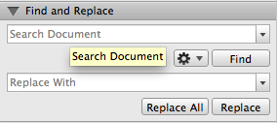

- Directions for Creating Folders:
Print each period’s label on a different color of paper
Cut out all of the boxes
Fold all of the boxes (“hot dog style”) that have the words in two different directions.

The smallest boxes are for hanging folders labels. Place the folded label in a clear plastic hanging folder tab and insert each filled-out label in a separate hanging folder

The middle-sized boxes are for file folder tab labels. Set the folded label to rest on a file folder tab. Use clear packaging table to adhere the label to the file tab and laminate the label simultaneously

The largest box is to go on the front (and back if desired) of each file folder. Be sure to match the label with the correct tab label and use packaging tape to adhere the label to the file folder
***There are some extra labels***
- Setup of Folders:
Student-Accessible Hanging Folders
-Place a set of hanging folders labeled for each period where students have easy access.
-Insert "Do Now” and “Turn In” folder for each period into its corresponding hanging folder
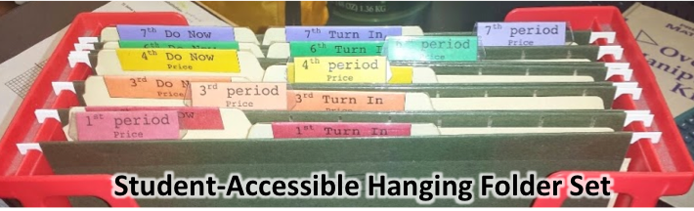

Teacher-Only-Accessible Hanging Folders
-Place the 2nd set of hanging folders labeled for each period where you have easy access (and the students do NOT)
-Insert "To Grade” and “Graded” folder for each period into its corresponding hanging folder
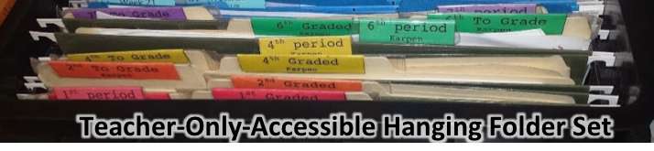

- Use of Folders:
-Keep Do Now papers in the “Do Now” folder throughout the week. Students can pick up their own paper as they come in, or you can hand them out. At the end of the week, either move “Do Now” folder to your teacher-only-accessible hanging folders, or transfer papers to “To Grade” folders

-When students complete an assignment, have them place papers in the “Turn-In” folder. At the end of period, day, or week, transfer these papers to “To Grade” folder”

-Once papers have been graded, transfer them to the “Graded” folder, and move the “Graded” folder to the Student-accessible set of hanging folders.

1st period  LastName | 1st period  LastName | 1st period  LastName | 1st period  LastName
1st period  LastName | 1st period  LastName | 1st period  LastName | 1st period  LastName

1st  To Grade LastName | 1st  Graded LastName | 1st  Turn In LastName | 1st  Do Now LastName
1st  To Grade LastName | 1st  Graded LastName | 1st  Turn In LastName | 1st  Do Now LastName
1st To Grade  LastName | 1st To Grade  LastName | 1st Graded  LastName | 1st Graded  LastName | 1st Do Now  LastName | 1st Do Now  LastName | 1st Turn In  LastName | 1st Turn In  LastName

1st period  LastName | 1st period  LastName
1st period  LastName | 1st period  LastName

2nd period  LastName | 2nd period  LastName | 2nd period  LastName | 2nd period  LastName
2nd period  LastName | 2nd period  LastName | 2nd period  LastName | 2nd period  LastName

2nd  To Grade LastName | 2nd  Graded LastName | 2nd  Turn In LastName | 2nd  Do Now LastName
2nd  To Grade LastName | 2nd  Graded LastName | 2nd  Turn In LastName | 2nd  Do Now LastName
2nd To Grade  LastName | 2nd To Grade  LastName | 2nd Graded  LastName | 2nd Graded  LastName | 2nd Do Now  LastName | 2nd Do Now  LastName | 2nd Turn In  LastName | 2nd Turn In  LastName

2nd period  LastName | 2nd period  LastName
2nd period  LastName | 2nd period  LastName

3rd period  LastName | 3rd period  LastName | 3rd period  LastName | 3rd period  LastName
3rd period  LastName | 3rd period  LastName | 3rd period  LastName | 3rd period  LastName

3rd  To Grade LastName | 3rd  Graded LastName | 3rd  Turn In LastName | 3rd  Do Now LastName
3rd  To Grade LastName | 3rd  Graded LastName | 3rd  Turn In LastName | 3rd  Do Now LastName
3rd To Grade  LastName | 3rd To Grade  LastName | 3rd Graded  LastName | 3rd Graded  LastName | 3rd Do Now  LastName | 3rd Do Now  LastName | 3rd Turn In  LastName | 3rd Turn In  LastName

3rd period  LastName | 3rd period  LastName
3rd period  LastName | 3rd period  LastName

4th period  LastName | 4th period  LastName | 4th period  LastName | 4th period  LastName
4th period  LastName | 4th period  LastName | 4th period  LastName | 4th period  LastName

4th  To Grade LastName | 4th  Graded LastName | 4th  Turn In LastName | 4th  Do Now LastName
4th  To Grade LastName | 4th  Graded LastName | 4th  Turn In LastName | 4th  Do Now LastName
4th To Grade  LastName | 4th To Grade  LastName | 4th Graded  LastName | 4th Graded  LastName | 4th Do Now  LastName | 4th Do Now  LastName | 4th Turn In  LastName | 4th Turn In  LastName

4th period  LastName | 4th period  LastName
4th period  LastName | 4th period  LastName

5th period  LastName | 5th period  LastName | 5th period  LastName | 5th period  LastName
5th period  LastName | 5th period  LastName | 5th period  LastName | 5th period  LastName

5th  To Grade LastName | 5th  Graded LastName | 5th  Turn In LastName | 5th  Do Now LastName
5th  To Grade LastName | 5th  Graded LastName | 5th  Turn In LastName | 5th  Do Now LastName
5th To Grade  LastName | 5th To Grade  LastName | 5th Graded  LastName | 5th Graded  LastName | 5th Do Now  LastName | 5th Do Now  LastName | 5th Turn In  LastName | 5th Turn In  LastName

5th period  LastName | 5th period  LastName
5th period  LastName | 5th period  LastName

6th period  LastName | 6th period  LastName | 6th period  LastName | 6th period  LastName
6th period  LastName | 6th period  LastName | 6th period  LastName | 6th period  LastName

6th  To Grade LastName | 6th  Graded LastName | 6th  Turn In LastName | 6th  Do Now LastName
6th  To Grade LastName | 6th  Graded LastName | 6th  Turn In LastName | 6th  Do Now LastName
6th To Grade  LastName | 6th To Grade  LastName | 6th Graded  LastName | 6th Graded  LastName | 6th Do Now  LastName | 6th Do Now  LastName | 6th Turn In  LastName | 6th Turn In  LastName

6th period  LastName | 6th period  LastName
6th period  LastName | 6th period  LastName

7th period  LastName | 7th period  LastName | 7th period  LastName | 7th period  LastName
7th period  LastName | 7th period  LastName | 7th period  LastName | 7th period  LastName

7th  To Grade LastName | 7th  Graded LastName | 7th  Turn In LastName | 7th  Do Now LastName
7th  To Grade LastName | 7th  Graded LastName | 7th  Turn In LastName | 7th  Do Now LastName
7th To Grade  LastName | 7th To Grade  LastName | 7th Graded  LastName | 7th Graded  LastName | 7th Do Now  LastName | 7th Do Now  LastName | 7th Turn In  LastName | 7th Turn In  LastName

7th period  LastName | 7th period  LastName
7th period  LastName | 7th period  LastName

