a 3-sided polygon 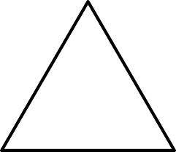 |  | a triangle with all 3 interior angles measuring < 90° 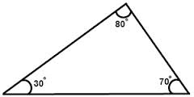
a triangle that has 3 unequal sides  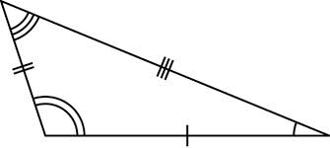 |  | a triangle in which one of the angles is >90°  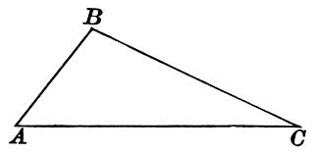
a triangle that has 2 or more sides that are equal  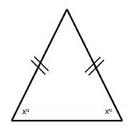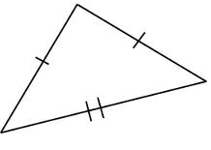 |  | a triangle with one 90° angle  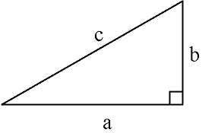
a triangle with all sides equal  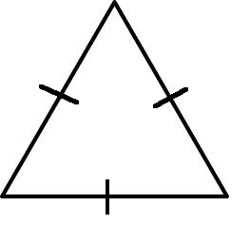 |  | a triangle with all angles equal (all 60°)  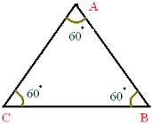
Acute Triangle |  |  | Geometry  by Sharrer  Triangles  p1/4  Triangle
Obtuse Triangle |  |  | Scalene Triangle  (scalen -”unequal”)
Right  Triangle |  |  | Isosceles Triangle  (iso -”equal”  sceles - “legs”)
Equiangular Triangle |  |  | Equilateral Triangle  (equi - equal”)
the longest side of a right triangle, opposite the right angle 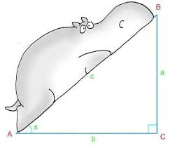 |  | $$=\frac{Opposite}{Hypotenuse}$$  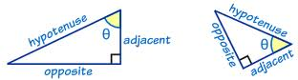
Leg² + Leg² = Hypotenuse²  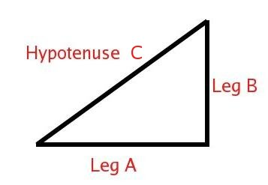 |  | $$=\frac{Adjacent}{Hypotenuse}$$
a set of three integers that can be the lengths of the sides of a right triangle  (work in the Pythagorean theorem)  EX: 3²+4² = 5², the numbers 3,4,5  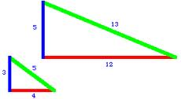 |  | $$=\frac{Opposite}{Ajacent}$$
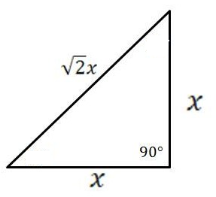 |  | 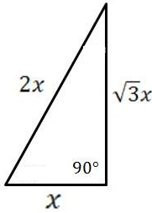
Sine = |  |  | Geometry  by Sharrer  Triangles  p2/4  Hypotenuse
Cosine = |  |  | Pythagorean Theorem
Tangent = |  |  | Pythagorean Triple
Sides of a 30-60-90 Triangle  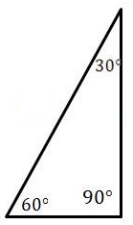 |  |  | Sides of a 45-45-90 Triangle  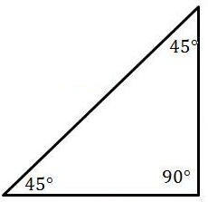
a line segment joining a vertex to the midpoint of the opposing side  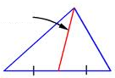 |  | formed when one side of a triangle is extended  $∡$d  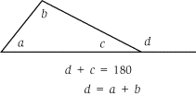
the perpendicular distance from the base to the opposite vertex  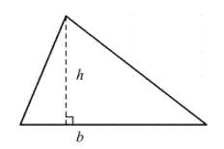 |  | For all Triangles, the sum of the shorter sides must be greater than the length of the largest side  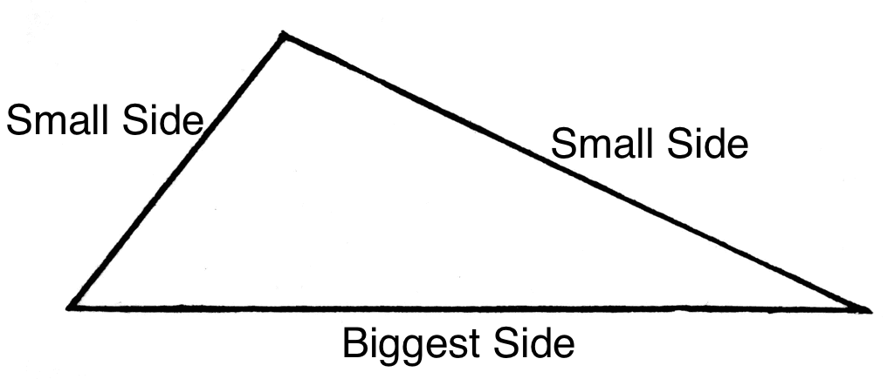  Small + Small > Big  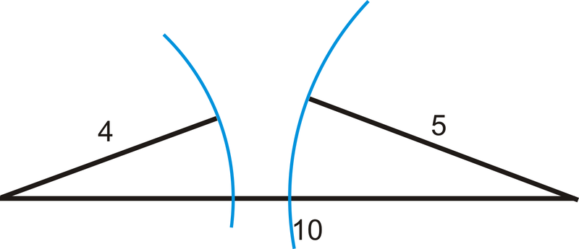
a line segment that bisects one of the vertex angles of a triangle  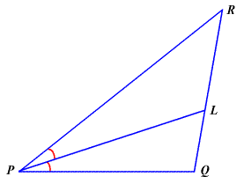  (bisect – to cut into 2 equal parts) |  | Short side opposite Smallest angle  Middle side opposite Middle angle  Largest side opposite Largest angle  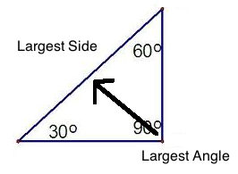
a segment, ray, line, or plane that is perpendicular to a segment at its midpoint  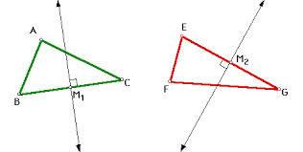 |  | a segment that connects the midpoints of two sides of a triangle; connects two midpoints of triangle; parallel to and 1/2 length of side below it  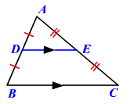
Exterior Angle  of a  Triangle  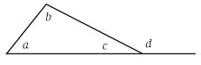 |  |  | Geometry  by Sharrer  Triangles  p3/4  Median  of a  Triangle
Given 3 lengths,  determine if a triangle is possible |  |  | Height  aka  Altitude  of a  Triangle
Given 3 angles  of a  Triangle,  determine the short, middle,  and long sides |  |  | Angle Bisector  of a  Triangle
Midsegment  of a  Triangle |  |  | Perpendicular Bisector  of a  Triangle
ASA  AAS  SSA  AAA  SSS  HL  (no ASS) |  | =180°
a segment that connects the midpoints of two sides of a triangle; connects two midpoints of triangle; parallel to and 1/2 length of side below it |  | Triangles that have the same angles, but not necessarily the same side lengths  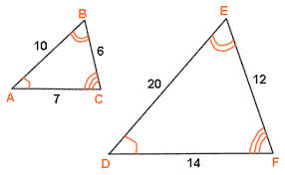  The sides must be proportional  SSS, SAS, AA
-this can be any side of a triangle.  -usually the side of a triangle drawn on the bottom |  | Right Triangle- the two sides that form a right triangle  Isosceles Triangle- the two equal sides  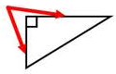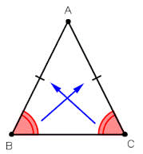
the amount of space inside the boundary of a triangle  = ½ base*height  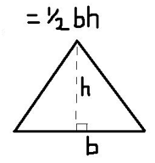 |  | the total distance around the outside of a triangle  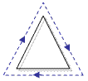  =Side1 + Side2 + Side3
Sum of the angles of a  Triangle  = |  |  | Geometry  by Sharrer  Triangles  p4/4  Congruent Triangles  ($≅$)
Similar  Triangles  (~) |  |  | Midsegment  of a  Triangle
Legs  of a  Triangle |  |  | Base  of a  Triangle
Perimeter of a  Triangle  P_{Triangle} = ? |  |  | Area  of a  Triangle  A_{Triangle} = ?

