Special Right Triangles | 30°-60°-90°  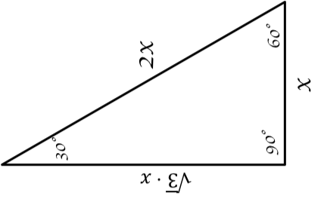
45°-45°-90°

