a shape with all points the same distance from its center  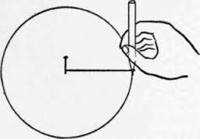 |  | the point which is equidistant from all points on the circle
any straight line segment that passes through the center of the circle and whose endpoints lie on the circle |  | any straight line segment whose endpoints lie on the center and the circle
line segment whose endpoints both lie on the circle |  | a straight line that cuts a curve in two or more parts.
a half of a circle or of its circumference. |  | -the portion of a disk enclosed by two radii and an arc  -similar to “pizza slices” of a circle  -Ex: Semicircle, Quarter circle
Center  of a  Circle |  |  | Geometry  by Sharrer  Circles  p1/4  Circle
Radius  of a  Circle |  |  | Diameter  of a  Circle
Secant  of a  Circle |  |  | Chord  of a  Circle
Sector  of a  Circle |  |  | Semicircle
the linear distance around the edge of a closed curve or circular object. |  | the amount of space occupied by a circle
two circles with the same  radii , diameter, or circumference |  | the amount of space occupied by a sector of a circle
- The central angles that create them are $≅$  - Their arcs are $≅$  - They are the same distance from the center |  | a line in the plane of the circle that intersects the circle in exactly one point  the point where a circle and a tangent intersect
circles that all have the same center |  | Then the line is perpendicular to the radius at the point of tangency
Area  of a  Circle  A_{Circle} = ? |  |  | Geometry  by Sharrer  Circles  p2/4  Circumference of a Circle  C = ?
Area  of a  Sector  A_{Sector} = ? |  |  | Circles are $≅$  when…
Tangent to a  Circle  Point of tangency  of a  Circle |  |  | Chords  are $≅$  when…
If a line is tangent to a circle  then… |  |  | Concentric Circles
The distance along the arc (part of the circumference of a circle) |  | the measure of an arc’s central angle
Arcs next to each other on the circumference of a circle |  | The measure of an arc formed by two adjacent arcs is the sum of the measures of the two arcs
these are equal if they have the same angle measure |  | $\hat{AB}$: the smaller of the two arcs formed when a circle is ÷ into 2 unequal parts.  $\hat{ACB}$: the larger of the two arcs formed when a circle is ÷ into 2 unequal parts.
an angle formed by two chords with the vertex on the circle |  | an angle formed by two radii with the vertex on the center
Arc Measure  of a  Circle |  |  | Geometry  by Sharrer  Circles  p3/4  Arc Length  (Def & Formula)  of a  Circle
Arc Addition Postulate  of a  Circle |  |  | Adjacent Arcs  of a  Circle
Minor Arc  &  Major Arc  of a  Circle |  |  | Arcs  are $≅$  when…
Central Angle |  |  | Inscribed Angle
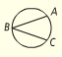  when the angle vertex is on the circle: |  | 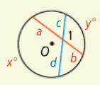
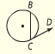  when the angle vertex is on the circle: |  | 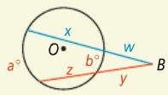
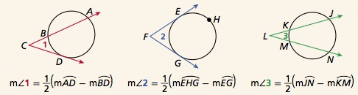 |  | 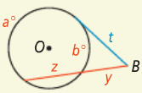
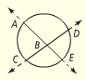 |  | 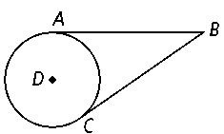
? |  |  | Geometry  by Sharrer  Circles  p4/4  ?
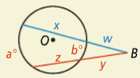  ? |  |  | ?
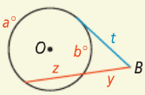  ? |  |  | 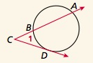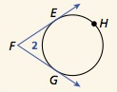  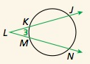  =?  =?  =?
$$\overline{BA}≅ ?$$ |  |  | ?

