Opposite/Adjacent  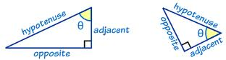 |  | When you look down at an object, the angle that your line of sight makes with a line drawn horizontally  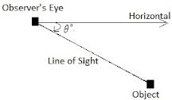
where a, b, and c represent the lengths of the sides of a triangle and c is the hypotenuse  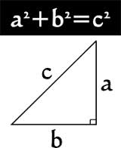 |  | When you look up at an object, the angle that your line of sight makes with a line drawn horizontally  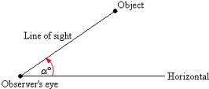
A set of three integers that can be the lengths of the sides of a right triangle  (work in the Pythagorean theorem)  EX: 3²+4² = 5², the numbers 3,4,5 are the ___________________  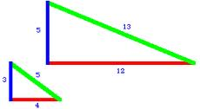 |  | Opposite/Hypotenuse
. |  | Adjacent/Hypotenuse
angle of depression |  |  | Geometry  by Sharrer  Ch 8  p1/1  Tangent
angle of elevation |  |  | Pythagorean Theorem
sine |  |  | Pythagorean Triple
cosine

