the central number in a geometric progression (e.g., 9 in 3, 9, 27 ), also calculable as the nth root of a product of n numbers.  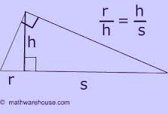 |  | Polygons in which the ratios of the measures of corresponding sides are equal and the corresponding angles are congruent.  (same shape, and angles, but not necessarily the same size)  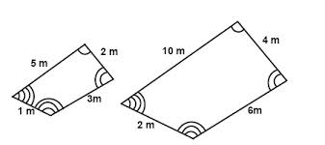
the average of a set of numerical values, calculated by adding them together and dividing by the number of terms in the set.  u+v+x+y+z  5 |  | An equation that equates two ratios  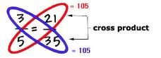
the quantitative relation between two amounts showing the number of times one value contains or is contained within the other.
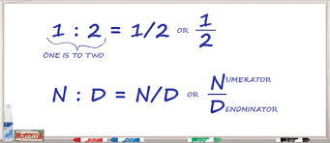
A multiple by which a figure is enlarged or reduced.
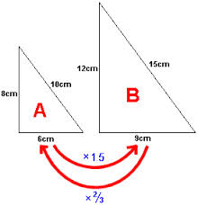
similar polygons |  |  | Geometry  by Sharrer  Ch 7  p1/1  geometric mean
proportions |  |  | arithmetic mean
ratio
scale factor

