a polygon with all sides congruent  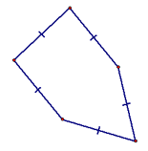 |  | = (n-2)180  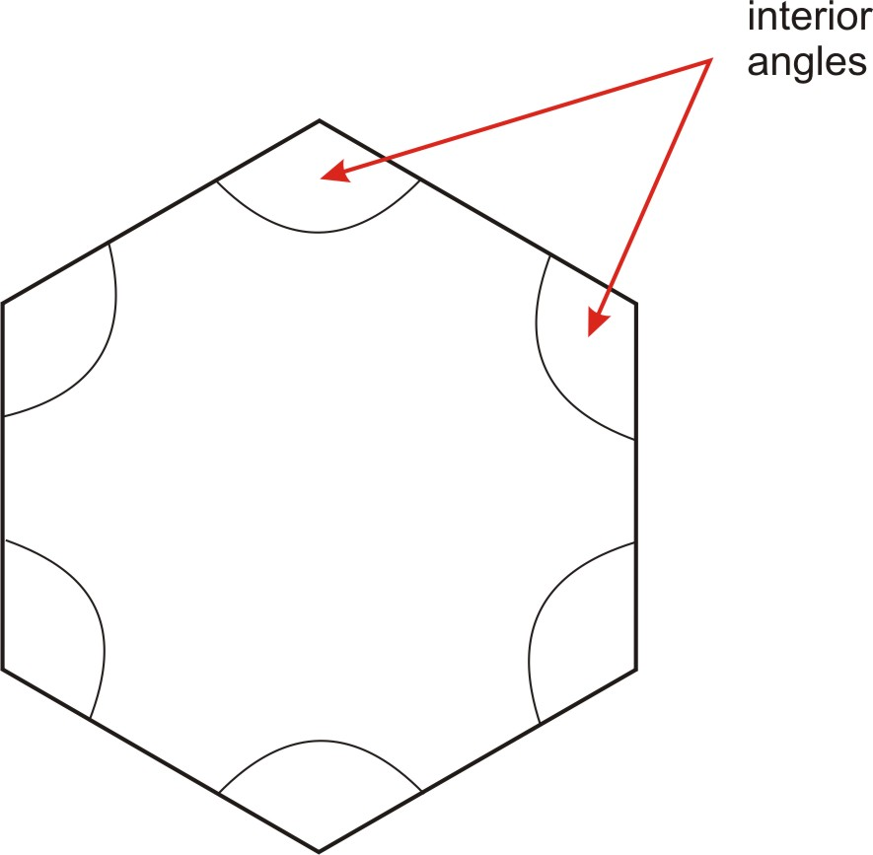
a polygon with all sides congruent  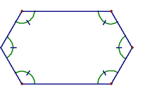 |  | = (n-2)180  n
a polygon that is BOTH equilateral and equiangular  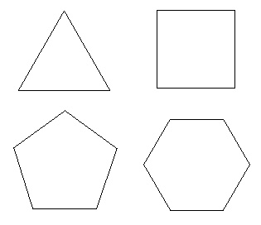 |  | = 360  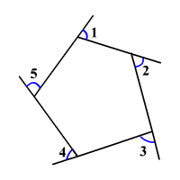
A closed plane figure formed by three or more segments  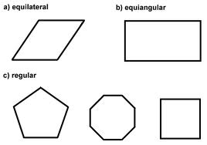 |  | = 360  n
(equation)  Sum of Int Ang. |  |  | Geometry  by Sharrer  Ch 6  p1/3  equilateral polygon
(equation)  1 Int Ang. |  |  | equiangular polygon
(equation)  Sum of Ext. Ang. |  |  | regular polygon
(equation)  1 Ext Ang. |  |  | polygon
=n  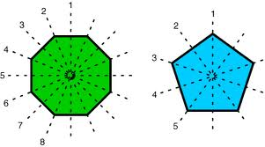 |  | 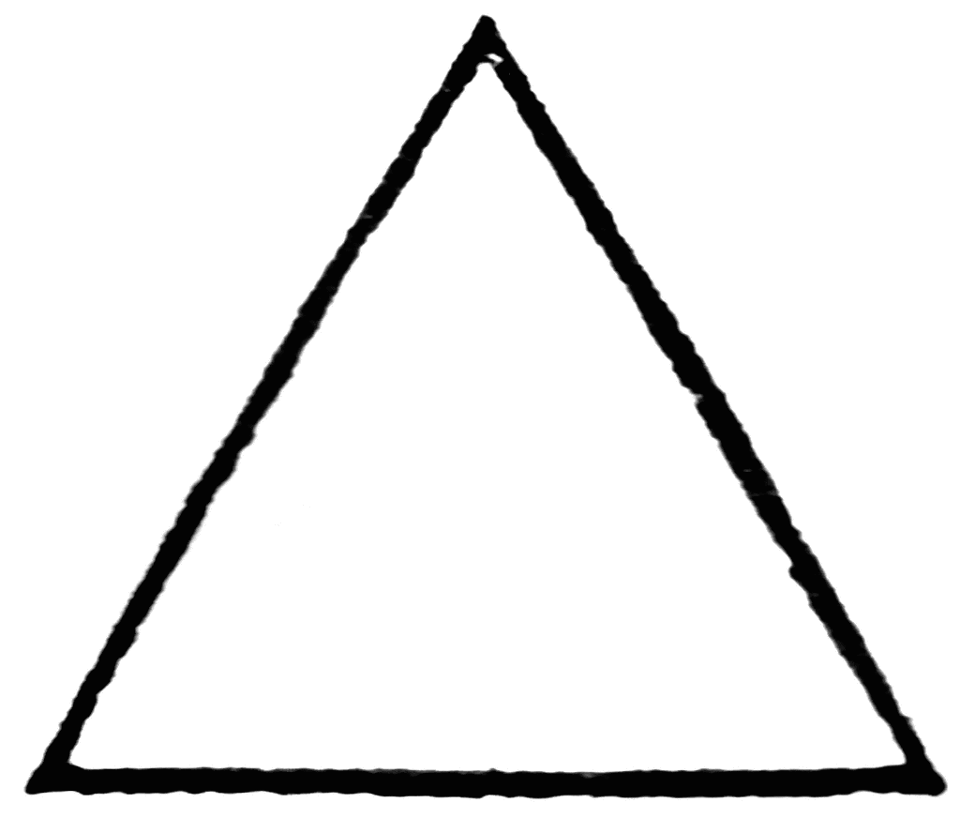  Triangle
= 360  n  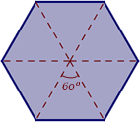 |  | Quadrilateral
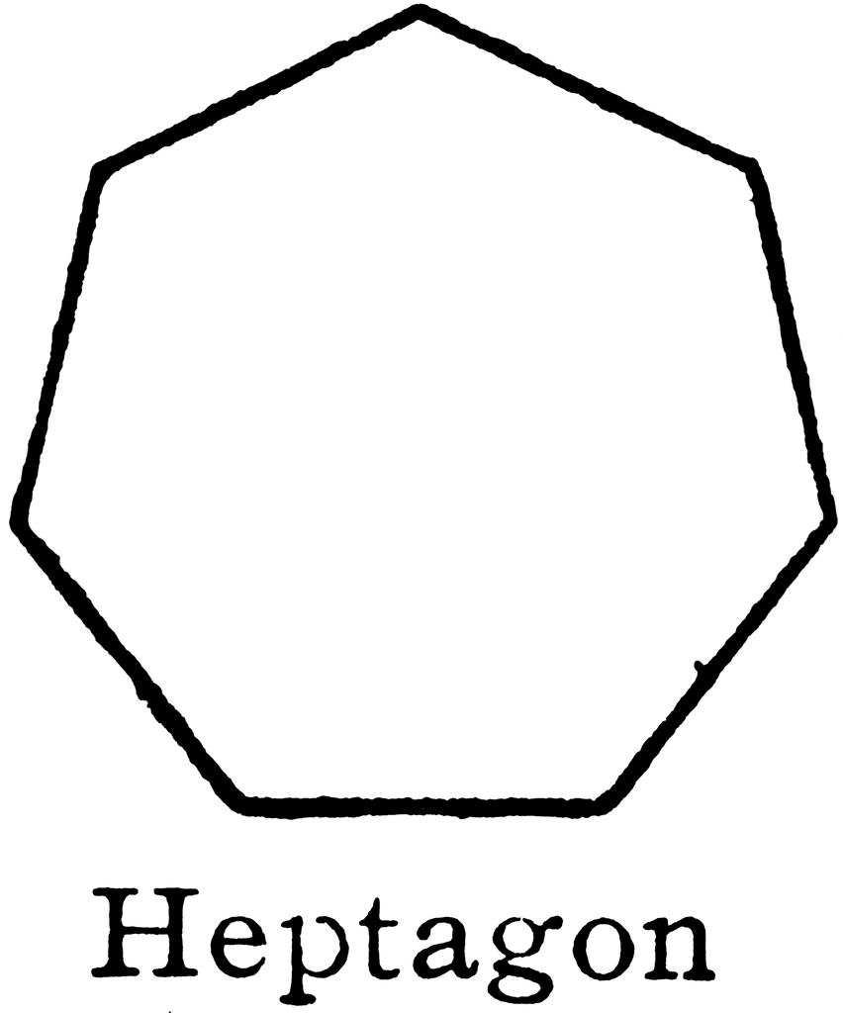 |  | 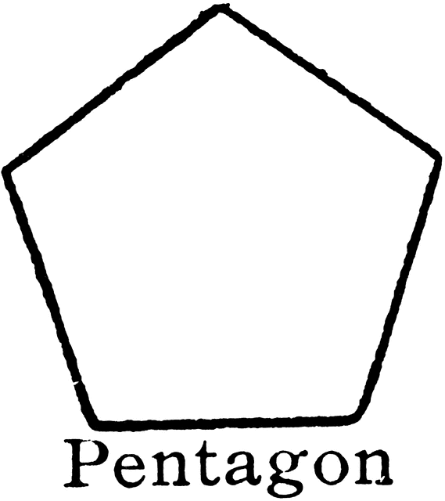
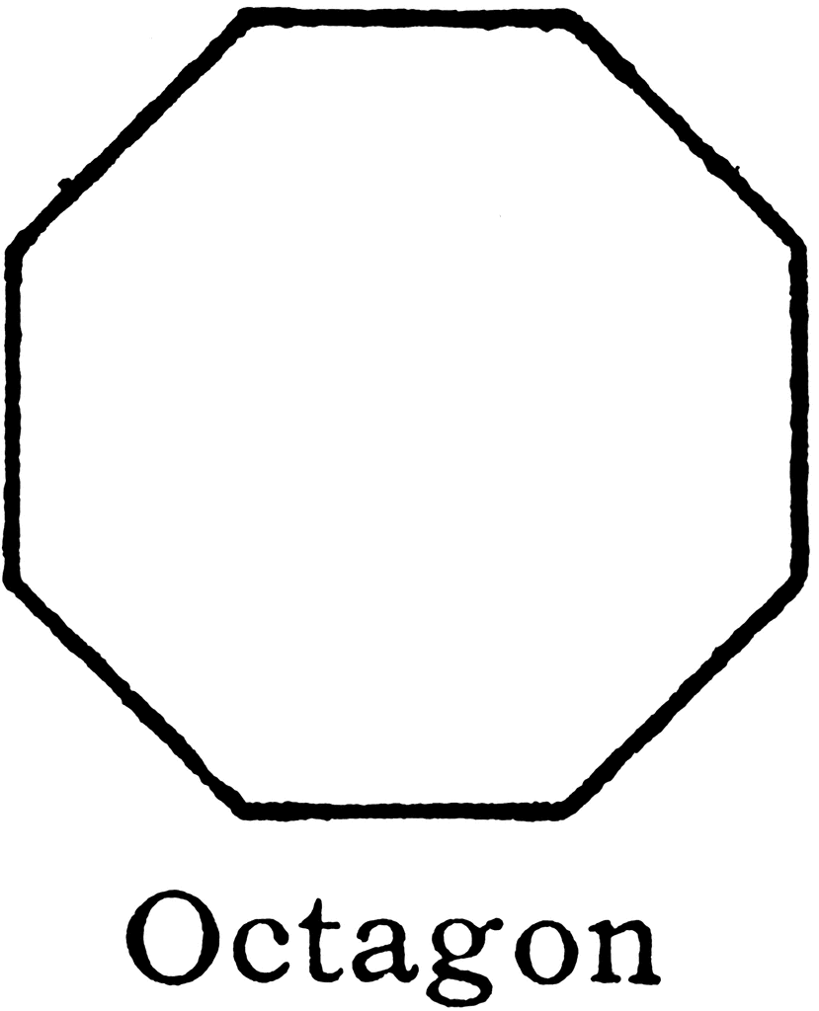 |  | 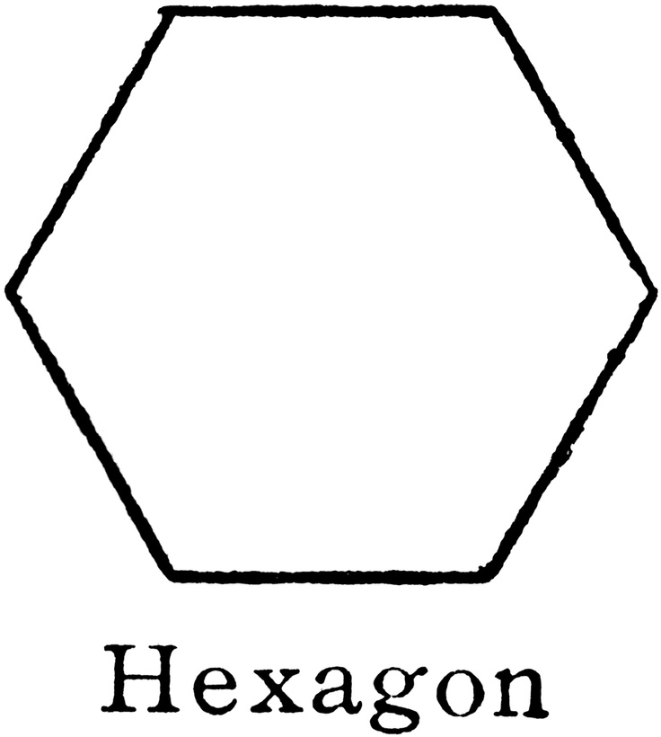
3-Sided Polygon |  |  | Geometry  by Sharrer  Ch 6  p2/3  (equation)  # of Lines of Symmetry
4-Sided Polygon |  |  | (equation)  Degree of Rotational Symmetry
5-Sided Polygon |  |  | 7-Sided Polygon
6-Sided Polygon |  |  | 8-Sided Polygon
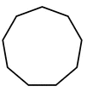  Nonagon |  | a quadrilateral with both pairs of opposite sides parallel  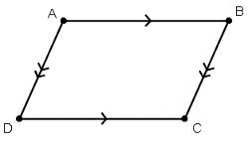
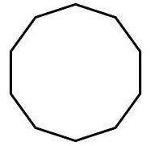  Decagon |  | a parallelogram with 4 congruent sides  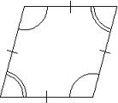
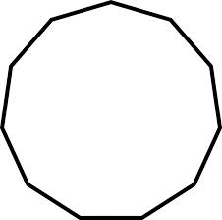  Undecagon |  | a parallelogram with 4 right angles
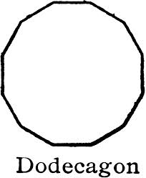 |  | a parallelogram with  4 congruent sides AND  4 right angles  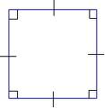
parallelogram |  |  | Geometry  by Sharrer  Ch 6  p3/3  9-Sided Polygon
rhombus |  |  | 10-Sided Polygon
rectangle |  |  | 11-Sided Polygon
square |  |  | 12-Sided Polygon

