3 medians connecting to vertices  Intersection of the medians of a triangle  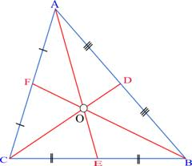 |  | a ___________ of a triangle is a line segment joining a vertex to the midpoint of the opposing side  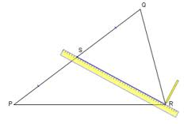
The point of concurrency of the three perpendicular bisectors of a triangle  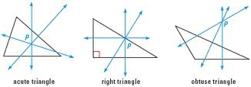 |  | Height  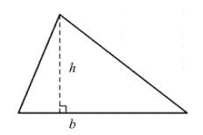
Point of Concurrency for Angle Bisector  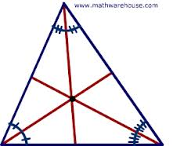 |  | A segment, ray, line, or plane that is perpendicular to a segment at its midpoint  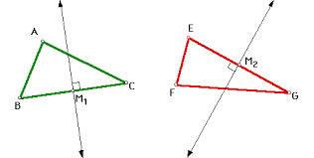
a segment that connects the midpoints of two sides of a triangle; connects two midpoints of triangle; parallel to and 1/2 length of side below it  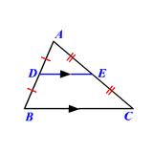 |  | A ray that divides an angle into two congruent angles.  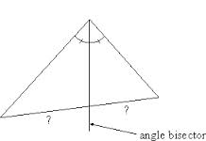
median  of a  Triangle |  |  | Geometry  by Sharrer  Ch 5  p1/1  centroid  of a  Triangle
altitude  of a  Triangle |  |  | circumcenter  of a  Triangle
perpendicular bisector  of a  Triangle |  |  | incenter  of a  Triangle
angle bisector  of a  Triangle |  |  | midsegment  of a  Triangle

