Polygons that have corresponding sides congruent and corresponding angles congruent  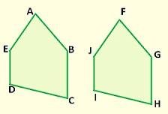 |  | A triangle with all angles congruent  all angles equal 60 degrees  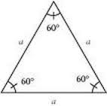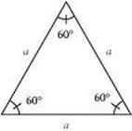
A triangle with no equal sides  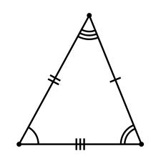 |  | 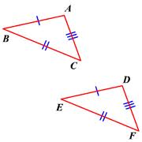
a triangle with two equal sides  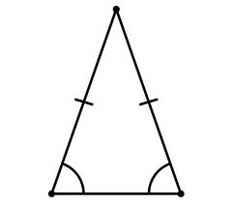 |  | 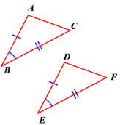
A triangle with 3 congruent sides.  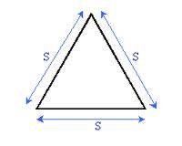 |  | 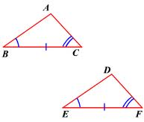
equiangular triangle |  |  | Geometry  by Sharrer  Ch 4  p1/2  congruent polygons
SSS  (Side Side Side) |  |  | scalene triangle
SAS  (Side Angle Side) |  |  | isosceles triangle
ASA  (Angle Side Angle) |  |  | equilateral triangle
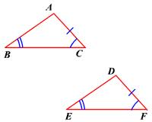
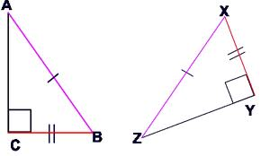
a statement that indicates that two polygons are congruent by listing the vertices in the order of correspondence
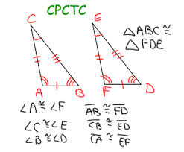
Geometry
by Sharrer
Ch 4
p2/2

AAS
(Angle Angle Side)

HL
(Hypotenuse-Leg)

 |  |  | congruence statement

