A line that intersects two coplanar lines at two distinct points.  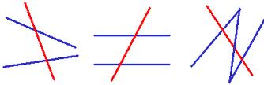 |  | A pair of interior angles on the same side of the transversal  these are supplementary  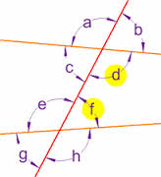
Angles that lie within a pair of lines and on opposite side of a transversal.  these are congruent  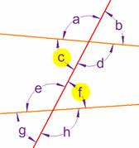 |  | Rise over run  (y₂-y₁)/(x₂-x₁)  the steepness of a line  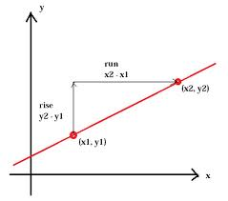
Angles that lay outside the parallel lines and are on opposite sides of the transversal;  these are congruent.  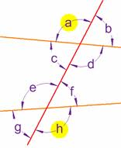 |  | y=mx + b where m is the slope and b is the y-intercept  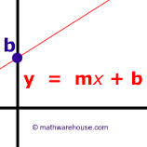
A pair of angles which are on the same side of the transversal, one must be interior, one must be exterior, and they must be nonadjacent
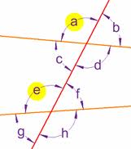
consecutive interior angles |  |  | Geometry  by Sharrer  Ch 3  p1/1  transversal
slope |  |  | alternate interior angles
slope-intercept form of a line |  |  | alternate exterior angles
 |  |  | corresponding angles

