an exact position or location on a plane surface  . |  | A figure formed by two rays with a common endpoint.  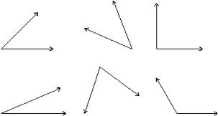
a continuous extent of length, straight or curved, without breadth or thickness  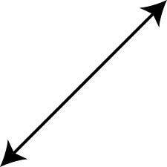 |  | are a pair of angles with a common vertex and a common side, but no common interior points  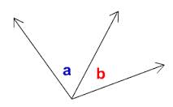
a part of a line with 2 endpoints |  | A pair of opposite congruent angles formed by intersecting lines  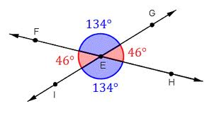
A flat surface that extends infinitely in all directions.  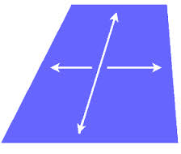 |  | Two adjacent angles that form a straight line  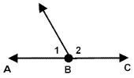
angle |  |  | Geometry  by Sharrer  Ch 1  p1/3  point
adjacent angle |  |  | line
vertical angles |  |  | line segment
linear pair |  |  | plane
2 angles whose sum is 90 degrees  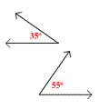 |  | An angle that measures more than 90 degrees but less than 180 degrees.  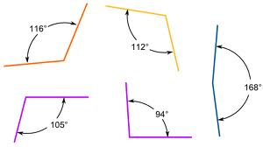
2 angles whose sum is 180 degrees  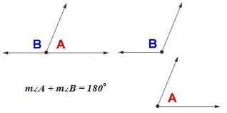 |  | An angle that is 180 degrees
An angle less than 90 degrees  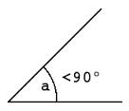 |  | A part of a line, with one endpoint, that continues without end in one direction  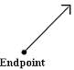
90 degree angle  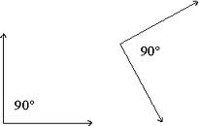 |  | A ray that divides an angle into two congruent angles.  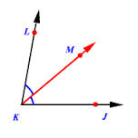
obtuse angle |  |  | Geometry  by Sharrer  Ch 1  p2/3  complementary angles
straight angle |  |  | supplementary angles
ray |  |  | acute angle
angle bisector |  |  | right angle
A point that divides the segment into two congruent segments.  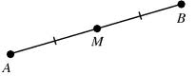 |  | The point in common of the two rays that form an angle.  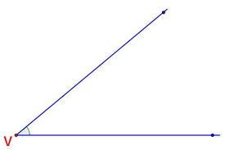
Points on the same line  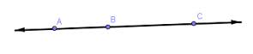 |  | Two lines on a plane that never meet. They are always the same distance apart.  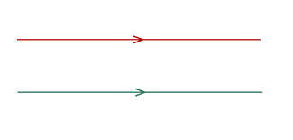
objects that lie on the same plane.  the plane doesn’t have to be visible  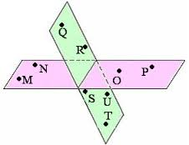 |  | Lines that intersect to form right angles.  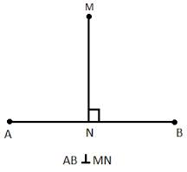
Angles that have equal measures  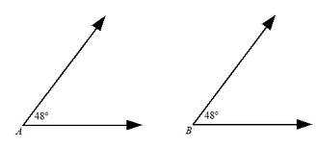 |  | = √(x₁-x₂)² + (y₁-y₂)²  aka "length"  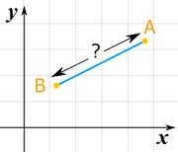
vertex of an angle |  |  | Geometry  by Sharrer  Ch 1  p3/3  midpoint
parallel lines |  |  | collinear points
perpendicular lines |  |  | coplanar objects
distance between two points |  |  | congruent angles

