a line in the plane of the circle that intersects the circle in exactly one point
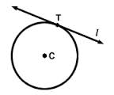
the point where a circle and a tangent intersect  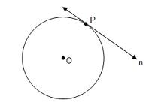 |  | a half of a circle or of its circumference.  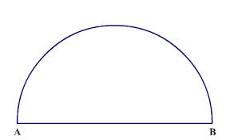
Then the line is perpendicular to the radius at the point of tangency  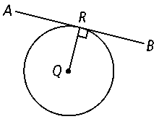 |  | the smaller of the two arcs formed when a circle is divided into two unequal parts.  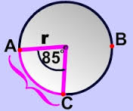
The larger arc joining two points on the circumference (edge) of a circle.
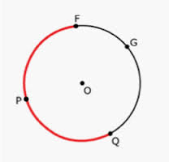
Geometry
by Sharrer
Circles
p1/4

Tangent to a circle

Semicircle |  |  | Point of tangency
Minor Arc |  |  | (theorem)  If a line is tangent to a circle  then…
Major Arc
a straight line that cuts a curve in two or more parts.  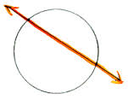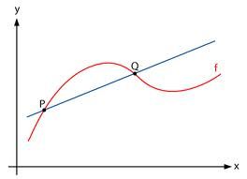 |  | circles that all have the same center  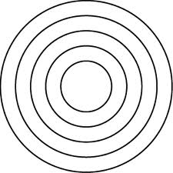
Arcs next to each other on the circumference of a circle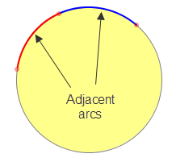  ____ |  | two circles with the same radii , diameter, or circumference  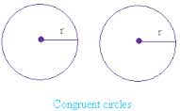
the linear distance around the edge of a closed curve or circular object.  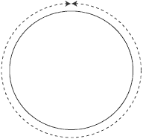 |  | these are equal if they have the same angle measure  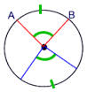
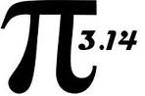 |  | - The central angles that create them are $≅$  - Their arcs are $≅$  - They are the same distance from the center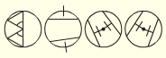
Concentric Circles |  |  | Geometry  by Sharrer  Circles  p2/4  Secant
Circles are $≅$  when… |  |  | Adjacent Arcs
Arcs  are $≅$  when… |  |  | circumference  (define)
Chords  are $≅$  when… |  |  | pi
The distance along the arc (part of the circumference of a circle, or any curve)
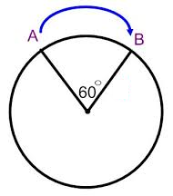

The measure of an arc formed by two adjacent arcs is the sum of the measures of the two arcs  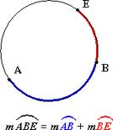 |  | the measure of an arc’s central angle  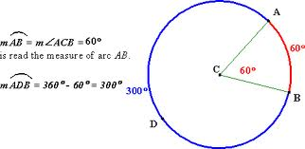
$$=πr^{2}$$ |  | …
this is the product of the ratio |  | …
Arc Length |  |  | Geometry  by Sharrer  Circles  p3/3
Arc Measure |  |  | Arc Addition Postulate
. |  |  | Circumference of a Circle (formula)  C=
 |  |  | Arc Length (theorem)
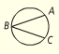  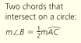 |  | 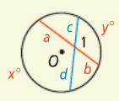
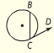  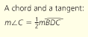 |  | 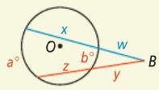
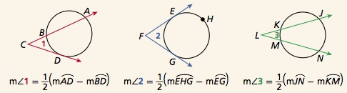 |  | 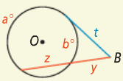
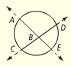  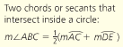 |  | 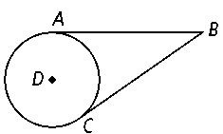  $$\overline{BA}≅\overline{BC}$$
? |  |  | Geometry  by Sharrer  Circles  p4/4  ?
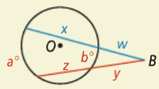  ? |  |  | ?
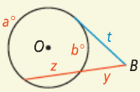  ? |  |  | 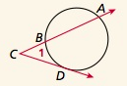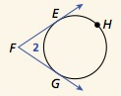  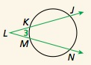  =?  =?  =?
$$\overline{BA}≅ ?$$ |  |  | ?

