… |  | ….
… |  | a half of a circle or of its circumference.  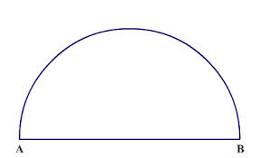
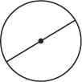 |  | the smaller of the two arcs formed when a circle is divided into two unequal parts.  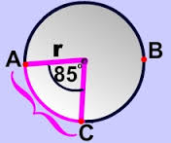
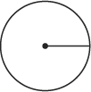 |  | The larger arc joining two points on the circumference (edge) of a circle.  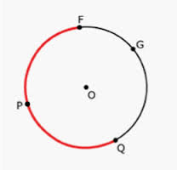
Central Angle |  |  | Geometry  by Sharrer  Circles  Ch 10.6 &12  p1/?  Circle
Semicircle |  |  | Center
Minor Arc |  |  | Diameter
Major Arc |  |  | Radius
circles that all have the same center
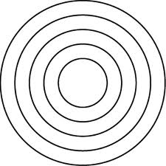
Arcs next to each other on the circumference of a circle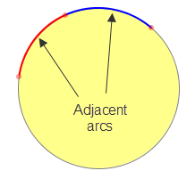  ____ |  | The distance along the arc (part of the circumference of a circle, or any curve)  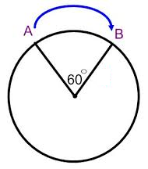
the linear distance around the edge of a closed curve or circular object.  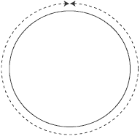 |  | these are equal if they have the same angle measure  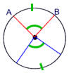
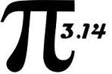 |  | two circles with the same radii , diameter, or circumference  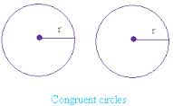
Arc Measure |  |  | Geometry  by Sharrer  Ch 10 Sec 6  p2/?  Concentric Circles
Arc Length |  |  | Adjacent Arcs
Congruent Arcs |  |  | circumference
Congruent Circles |  |  | pi
… |  | 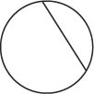
… |  | …
… |  | …
… |  | …
Chord |  |  | Geometry  by Sharrer  Ch 10 Sec 6  p3/?  Arc Measure (Concept)
Inscribed Angle |  |  | Arc Addition Postulate
Intercepted Arc |  |  | Circumference of a Circle (formula)
Locus |  |  | Arc Length (theorem)
… |  | …
… |  | …
… |  | …
… |  | …
Secant |  |  | Geometry  by Sharrer  Ch 10 Sec 6  p2/?  …
Standard form of an equation of a circle |  |  | …
… |  |  | …
… |  |  | …

