Complementary Angles
2 angles that add to be 90°
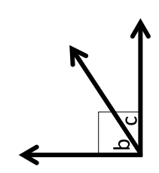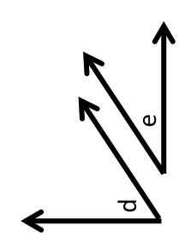
∡d +∡e = 90° ∡b +∡c = 90°
Alternate Exterior Angles
Opposite & Outside of parallel lines

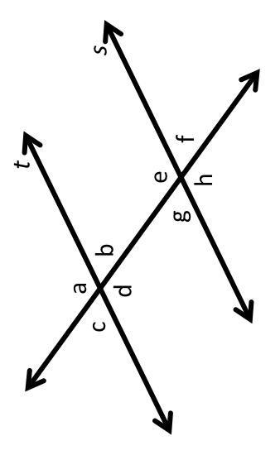
Alternate Interior Angles
Opposite & Inside of parallel lines

Vertical Angles
Opposite angles on Intersecting lines

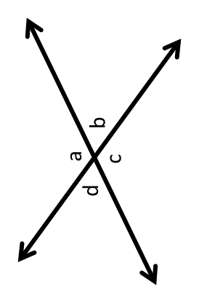
Linear Pairs
2 angles that form a line and are touching

Corresponding Angles
2 angles in the “Same Position” or matching spots
Supplementary Angles
2 angles that add to be 180°
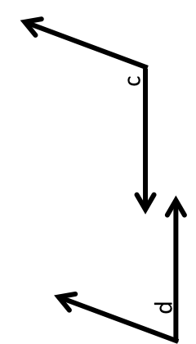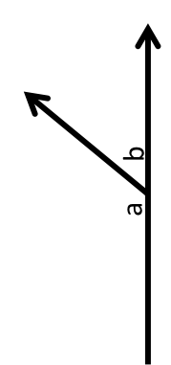
∡a +∡b = 180° ∡d +∡c = 180°
Transversal
A Line that crosses at least 2 other lines

