Democritus
-all things made of particles
Dalton
-atomic theory
Thompson
-discovered electrons

-plum pudding model

-cathode ray tube experiment
Rutherford
-discovered nucleus
-gold foil experiment
Millikan
-discovery of charge and mass of electron
-oil drop experiment

Bohr
-planetary model of atom
Mendeleev
-periodic table by atomic mass
Moseley
-periodic table by atomic number
Heisenberg
-uncertainty principle

(can’t know position and momentum
of electron at the same time)
Exothermic
Reaction
means “out of”

-Heat is released

-Temperature goes up

-ΔH is negative
Exothermic
Reaction
(graph)
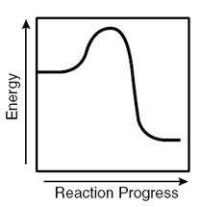
Endothermic
Reaction
means “into”

-Heat is absorbed

-Temperature goes down

-ΔH is positive
Endothermic
Reaction
(graph)
