Equation of a Line |  | Y-Intercept Form  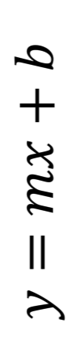  Equation for Slope  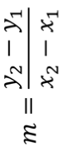
 |  | 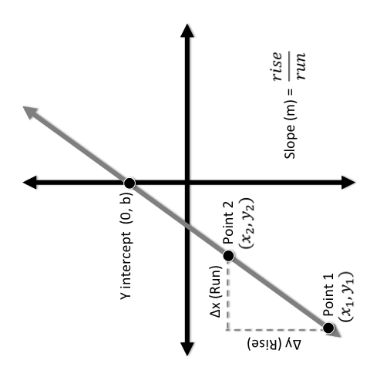
Determining Slope (m) |  | Equation for Slope  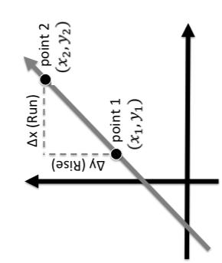  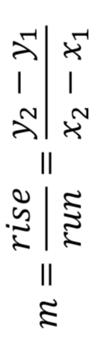
Sign of Slope
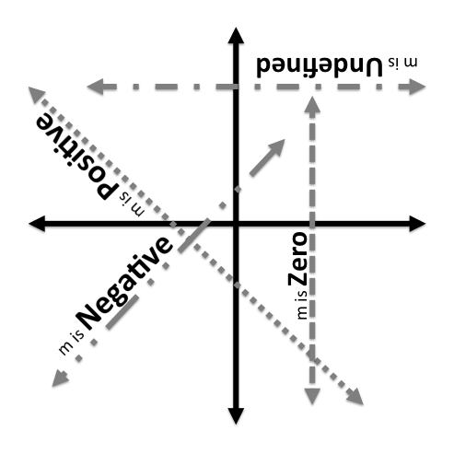
Slope | 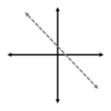 |  | 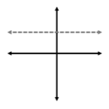
 | Slope is Negative  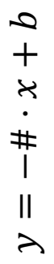 |  | 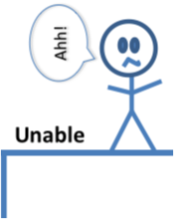  Slope is Undefined  x = #
 | 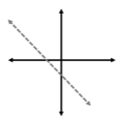 |  | 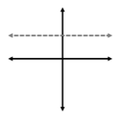
 | Slope is Positive  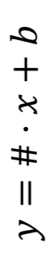 |  | Slope is Zero  y = #

