Angles
Exponents
The Product Rule

$$a^{m}⋅a^{n}=a^{m+n}$$

examples:

$t^{4}⋅t^{2}=t^{4+2}=t^{6}$ $3^{8}⋅3^{4}=3^{8+4}=3^{12}$
Exponents
The Quotient Rule

$$\frac{a^{m}}{a^{n}}=a^{m-n}$$

examples:

$\frac{x^{6}}{x^{4}}=x^{6-4}=x^{2}$ $\frac{2^{8}}{2^{3}}=2^{8-3}=2^{5}$
Exponents
The Power Rule

$${\left(a^{m}\right)}^{n}=a^{m⋅n}$$

examples:

${\left(b^{4}\right)}^{3}=b^{4⋅3}=b^{12}$ ${\left(4^{5}\right)}^{6}=4^{5⋅6}=4^{30}$
Exponents
Product to a Power

$${\left(ab\right)}^{n}=a^{n}b^{n}$$

examples:

${\left(rw\right)}^{2}=r^{2}w^{2}$ ${\left(5t\right)}^{3}=5^{3}t^{3}$
Exponents
Quotient to a Power

$${\left(\frac{a}{b}\right)}^{n}=\frac{a^{n}}{b^{n}}$$

examples:

${\left(\frac{y}{z}\right)}^{4}=\frac{y^{4}}{z^{4}}$ ${\left(\frac{4}{d}\right)}^{5}=\frac{4^{5}}{d^{5}}$
Exponents
Exponent of 1

$$a^{1}=a$$

examples:

$h^{1}=h$ $7^{1}=7$ ${99}^{1}=99$
Exponents
Exponent of 0

$$a^{0}=1$$

examples:

$x^{0}=1$ $9^{0}=1$ ${67908615}^{0}=1$
Exponents
Negative Exponent

$a^{-n}=\frac{1}{a^{n}}$ and $\frac{1}{b^{-n}}=b^{n}$

examples:
$k^{-4}=\frac{1}{k^{4}}$ ${t^{2}7}^{-3}=\frac{t^{2}}{7^{3}}$ $\frac{1}{p^{-5}}=p^{5}$ $\frac{3^{-5}}{x^{-6}}=\frac{x^{6}}{3^{5}}$
$$.$$
Exponents
Parts
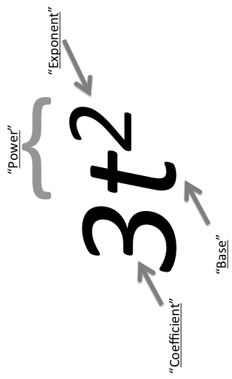
Exponents
Radical to Exponent Form

$$a^{\frac{m}{n}}=\sqrt[n]{a^{m}}$$

examples:

$b^{\frac{7}{3}}=\sqrt[3]{b^{7}}$ $6^{\frac{11}{2}}=\sqrt{6^{11}}$
Radical
Parts
