(top)
>
greater than
(top)
<
less than
Range of a function
(definition)
the y values
Domain of a function
(definition)
the x values
What is the Range of

$\left(2,0\right) \left(3,6\right) \left(-2,4\right)$?
$$\left\{0,6,4\right\}$$
What is the Domain of

$\left(2,0\right) \left(3,6\right) \left(-2,4\right)$?
$$\left\{2,3,-2\right\}$$
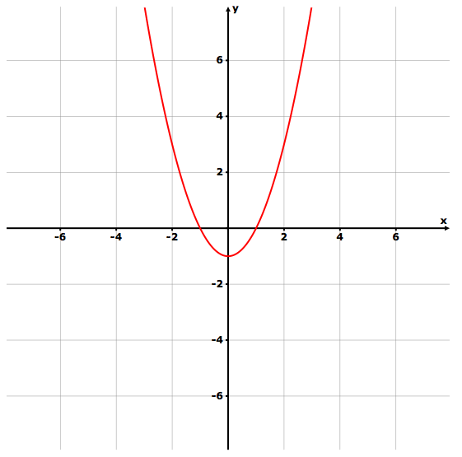
What is the Domain of:

x = all real numbers
What is the Range of:

$$y≥-1$$
A Function
(definition)
-has no repeating x values
-passes the vertical “line test”
No
(-4,2) (-3,0) (-4,1)
Yes
(-4,6) (-1,6) (2,1)

Slope
(Formula)
$$=\frac{y_{2}-y_{1}}{x_{2}-x_{1}}$$
Mean
(definition)
the average of a set of numbers

example:
$$=\frac{20+24+30+22+29}{5}=25$$
Median
(definition)
the middle number in a set of data

example:
(17.5)
3 16 15 ⬆ 20 21 24

2 5 7 8 8 10 18 21 21 23 25
What does “m” represent?
⬇
$$y=mx+b$$
$$y=mx+b$$

slope

What does “b” represent?
⬇    
$$y=mx+b$$
$$y=mx+b$$

y-intercept

What is the phrase that helps you to know how to determine slope?

(“______ over ______”)
$\frac{rise}{run}$

Horizontal Line
(slope)
m = 0

slope is zero
Vertical Line
(slope)
m = undefined

slope is undefined
Horizontal Line
(equation)
y = #
(y equals a number)

example:
y=4
Vertical Line
(equation)
x = #
(x equals a number)

example:
x=4
Horizontal Line
(graph)
example:
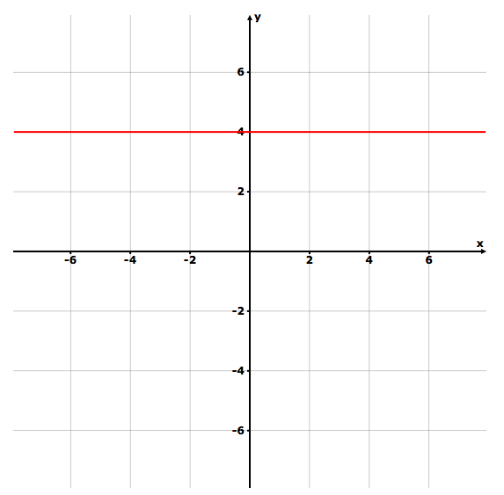
Vertical Line
(graph)
example:
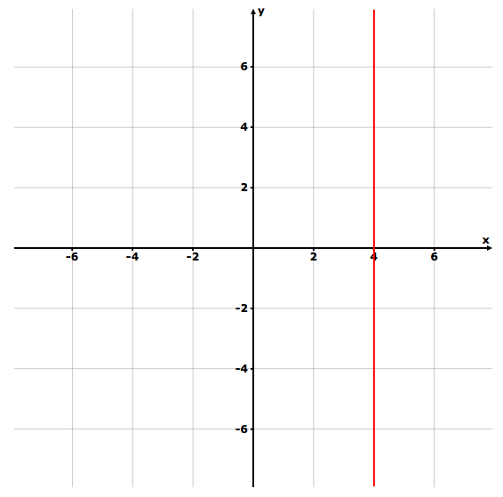
Direct Variation
(graph)
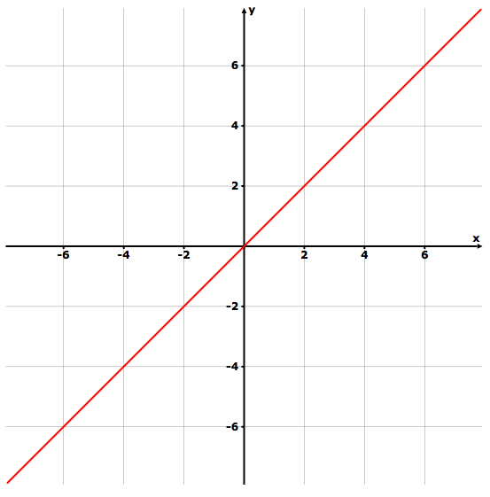
linear equation that passes through the origin
Inverse Variation
(graph)
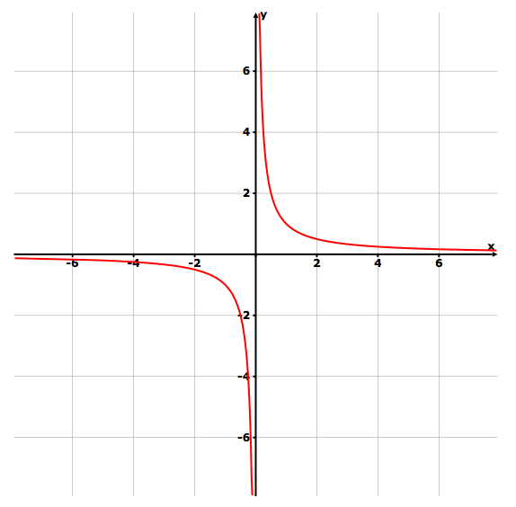
Direct Variation
(equation)
y = k x

(y =mx+0)
Inverse Variation
(equation)
$$y=\frac{k}{x}$$
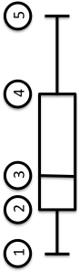

What do the vertical lines on a
Box and Whisker plot represent?
- Minimum
- Lower Quartile/Q1
- Median
- Upper Quartile/Q3
- Maximum
When the directions say

find “a Zero”

What do you do?
- replace “y” with “0”
- solve for x

- get equation into y = _______ form
- graph
- where the line crosses the x axis ( __,0)
When the directions say

find “the Root”

What do you do?
- replace “y” with “0”
- solve for x

- get equation into y = _______ form
- graph
- where the line crosses the x axis ( __,0)
When the directions say

find “the x-intercept”

What do you do?
- replace “y” with “0”
- solve for x

- get equation into y = _______ form
- graph
- where the line crosses the x axis ( __,0)
When the directions say

find “the y-intercept”

What do you do?
- replace “x” with “0”
- solve for y

- get equation into y = _______ form
- graph
- where the line crosses the y axis ( 0, __)
When the directions say

“What is $f\left(-8\right)$ for the function f ? $f\left(x\right)=\frac{11(x-24)}{2}$”

What do you do?
replace/substitute the “x” with -8

$$f\left(-8\right)=\frac{11(-32)}{2}$$

$$f\left(-8\right)=\frac{-352}{2}$$

$$f\left(x\right)=\frac{11(x-24)}{2}$$

$$f\left(-8\right)=\frac{11((-8)-24)}{2}$$

$$f\left(-8\right)=-176$$

Coordinate

( , )

example: (-2,6)
a. what does the 1st number represent?
b. what does the 2nd number represent?
( x , y )
example: (-2,6)

1st # = x value
2nd # = y value
example: x=-2; y=6
What does an

x-intercept

Coordinate look like?
( __,__ )
( __ , 0 )
What does a

y-intercept

Coordinate look like?
( __,__ )
( 0 , __ )
$$f\left(-8\right)=\frac{11((-8)-24)}{2}$$

$f\left(-8\right)=\frac{11(-32)}{2}$
$$f\left(-8\right)=\frac{-352}{2}$$
$$f\left(-8\right)=-176$$

$$y≥-1$$
$$f\left(x\right)=\frac{11(x-24)}{2}$$

