What symbol goes on TOP when converting
from smaller units to larger units?
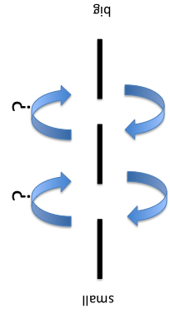
÷
division
What symbol goes on BOTTOM when converting from smaller units to larger units?

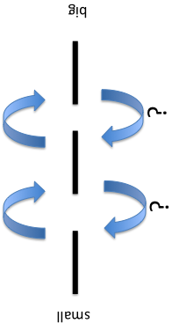
×
multiplication
English System Length Conversions

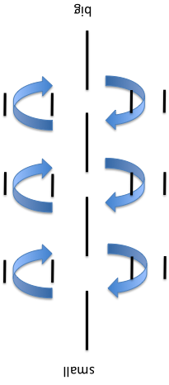
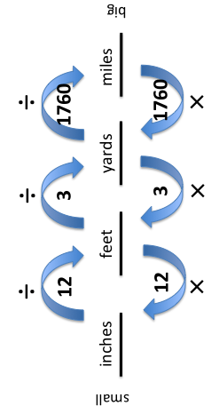
Metric System Length Conversions

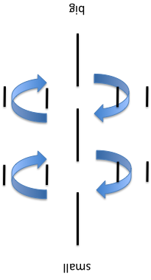
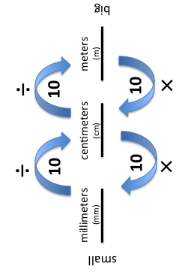
How many inches
are there in 1foot?

___in = 1ft
12
How many feet
are there in 1yard?

___ft = 1yd
3
How many yards
are there in 1mile?

___yds = 1mile
1760
How many millimeters
are there in 1centimeter?

___mm = 1cm
10
How many centimeters
are there in 1meter?

___cm = 1m
10
How many minutes
are there in 1hour?

___min = 1hr
60
What process should you use
for working a word problem?
“C U B E D”
What does “CUBED”
stand for?
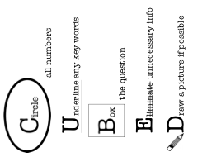
How do you convert
a fraction to a decimal?

example: $\frac{1}{5}$
$\frac{1}{5}$ denominator x ___ =100
5 x 20 = 100, so

$\frac{1}{5}× \frac{20}{20} =\frac{20}{100}$

then move the numerator’s decimal over 2 times
(if none is present, it is at the far right)
$$\frac{1}{5}=.20 or .2$$

